PENETRATION TESTING REPORT

FOOTPRINTING & NETWORK SCANNING PHASES
W2-PM-FINAL | CYBERSECURITY | NETWORKWALKS
Field | Details
Pentester/Trainee Name | Tijani Ayomide
Program/Batch | B083 – Networkwalks
Date | 17th September,2026.
Modules Completed | W2-PM1 – Footprinting with Kali Linux  W2-PM5 – Zenmap Scanning
Client/Target | - NetworkWalks  2.My own LAN Network
Permission Secured? | YES
Phases Covered | Phase 1: Reconnaissance & Footprinting  Phase 2: Scanning & Network Discovery

1. Liability Disclaimer
I performed these activities only within the authorized scope provided for this educational cybersecurity exercise and/or on systems and networks that I own or have permission to test.
The activities documented in this report were conducted for educational and research purposes as part of my cybersecurity training with Networkwalks. The information contained in this report should not be used to perform unauthorized access, scanning, enumeration, exploitation, or other activities against systems without appropriate permission.
Unauthorized security testing may violate organizational policies and applicable laws. All cybersecurity activities should therefore be performed responsibly and within an approved scope.

2. Introduction
This report documents my Week 2 practical activities as part of my Cybersecurity & Ethical Hacking internship with Networkwalks.
The project covered two major areas:
- Foot-printing and Reconnaissance using Kali Linu
- Network Scanning and Host Discovery using Zenmap
The foot-printing phase involved gathering publicly available information about an authorized domain (networkwalks.com) using multiple reconnaissance tools. The tools used included WHOIS, WhatWeb, Nslookup, Curl, Wafw00f, and DNSrecon.
The network scanning phase involved using Zenmap on a Windows PC to identify the local IP address and subnet, discover live hosts within the local network, identify their IP and MAC addresses, and generate a network topology.
The purpose of these exercises was to understand how cybersecurity professionals gather information about an environment before carrying out further security assessment activities.

3. Objectives
The main objectives of this practical were to:
- Understand the purpose of foot-printing and reconnaissance
- Obtain domain registration information using WHOIS.
- Identify web technologies using WhatWeb.
- Resolve domain names to IP addresses using Nslookup.
- Inspect HTTP response headers using Curl.
- Identify possible Web Application Firewall protection using Wafw00f
- Enumerate DNS records using DNSRecon.
- Identify the local IP address and LAN subnet.
- Discover live hosts within the local subnet using Zenmap.
- Identify the IP and MAC addresses of discovered hosts.
- Generate and save a network topology.
- Practice documenting cybersecurity findings professionally.

4. Tools Used
Tool | Purpose
Kali Linux | Operating system used for reconnaissance and security testing activities
WHOIS | Obtains publicly available domain registration information
WhatWeb | Identifies technologies used by a web application
Nslookup | Resolves domain names to IP addresses
Curl | Retrieves and examines HTTP response headers
Wafw00f | Checks for the presence of a Web Application Firewall
DNSRecon | Enumerates DNS records and related DNS information
Zenmap | Graphical interface for Nmap used for network scanning and host discovery
Nmap | Network scanning engine used by Zenmap
Windows CMD | Used to identify local network configuration

5. Activities Performed

5.1 Footprinting & Reconnaissance with Kali Linux
For the first part of the practical, I performed reconnaissance against the authorized domain [networkwalks.com] using six Kali Linux tools (whois, whatweb, nslookup, curl, wafw00f and dnsrecon). Each tool helped me gather a different type of information about the target.
I started with WHOIS, which I used to obtain publicly available information about the domain registration and its name servers. This gave me a better understanding of the domain and some of the infrastructure associated with it.
Next, I used WhatWeb to identify the technologies being used by the website. The scan revealed technologies such as WordPress 7.0.4 and WP Download Manager 3.3.58, as well as other technical information exposed by the website.
I then used Nslookup to find the IP address associated with the domain. The result returned 192.232.216.135.
After that, I used Curl with the -I option to examine the HTTP response headers from the website. This provided additional technical information about the web application and showed the WordPress REST API endpoint /wp-json/.
I also ran Wafw00f to check whether the website was protected by a Web Application Firewall. The tool identified ModSecurity (SpiderLabs) as the WAF.
Finally, I used DNSRecon to gather more information about the domain's DNS configuration. The results included details about name servers, mail servers, SPF/TXT records, service records, and DNS-related software.

5.2 Network Scanning with Zenmap
The second part of the practical involved network discovery using Zenmap on a Windows PC.
The objective was to identify the local network configuration, discover active hosts, identify their IP and MAC addresses, and generate a network topology.
The scan was performed against my own local authorized network.
I downloaded Zenmap from the official Nmap website and installed it on my Windows PC.
The next objective was to identify the local IP address assigned to the Windows PC and determine the LAN subnet.
I used the ipconfig or ipconfig /all to carry out this.
My result is attached at the evidence section.
The ipconfig command provided me with the network configuration of the Windows PC. I then used the IPv4 address and subnet information to determine the range of addresses to scan in Zenmap.
The next objective was to identify active hosts within the local network.
I entered my local subnet into Zenmap and performed a ping scan to identify devices that were active on the network.
The scan identified the following live hosts:
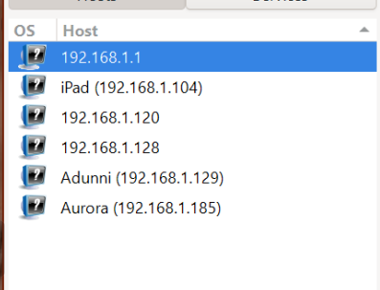
A total of 6 live hosts were identified during the network discovery scan (ping scan).
Other discoveries from the scan can be found attached in the evidence section.

After completing the network scan, I opened the Topology section in Zenmap and reviewed the discovered network devices.
The topology view provided a visual representation of the hosts discovered during the network scan.

- Findings and Risk Analysis
The following observations were identified during the foot-printing and network scanning exercises.
# | Finding / Observation | Evidence | Potential Security Relevance | Risk Level
1 | Web technologies identified | WhatWeb output | Technology information may assist further authorized enumeration | MEDIUM
2 | Domain IP address identified | Nslookup output | Provides information about the location of the web service | LOW
3 | HTTP headers exposed | Curl output | May reveal technical information about the web server/application | LOW
4 | WAF information identified | Wafw00f output | Provides information about deployed security infrastructure | LOW
5 | DNS records exposed | DNSRecon output | Can help build a profile of publicly accessible infrastructure | MEDIUM
The findings above are observations from reconnaissance and network discovery. The presence of exposed information does not automatically mean that a confirmed vulnerability exists.
No exploitation or vulnerability validation was performed as part of these exercises.

- Recommendations
Based on the observations from the practical exercises, the following security practices are recommended:

7.1 Review Publicly Exposed Information
Organizations should periodically review the information that can be obtained about their domains, websites, technologies, and infrastructure through publicly available reconnaissance techniques.

7.2 Keep Web Technologies Updated
Web servers, CMS platforms, plugins, frameworks, and other technologies should be regularly updated and reviewed for known security issues.

7.3 Review HTTP Response Headers
HTTP response headers should be reviewed to determine whether unnecessary technical information is being exposed.

7.4 Review DNS Records
DNS records should be reviewed periodically to ensure that only necessary information and services are publicly exposed.

7.5 Maintain WAF Configuration
Where a WAF is deployed, it should be appropriately configured, monitored, and maintained.

7.6 Perform Regular Network Discovery
Organizations should periodically perform authorized internal network discovery to identify active devices and maintain an accurate understanding of their network environment.

7.7 Investigate Unknown Devices
Unexpected devices identified during internal network scanning should be verified and investigated by the appropriate network or security personnel.

7.8 Maintain Network Documentation
Network addresses, devices, and topology information should be documented and kept up to date.

7.9 Perform Security Testing Within an Authorized Scope
Reconnaissance and scanning activities should only be performed against systems and networks where appropriate authorization has been obtained.

8. What I Learned
During this practical, I gained hands-on experience with different reconnaissance and network discovery techniques.
I learned how WHOIS can be used to obtain publicly available domain registration information and how WhatWeb can identify technologies associated with a website.
I also learned how Nslookup can be used to resolve domain names to IP addresses and how Curl can be used to inspect HTTP response headers.
Using Wafw00f, I learned how security professionals can identify possible Web Application Firewall technologies protecting a web application. With DNSRecon, I learned how DNS records can provide additional information about an organization's infrastructure.
During the network scanning exercise, I learned how to identify my local IP address and subnet using Windows CMD and how to use Zenmap/Nmap to discover active hosts on a local network.
I also learned how IP addresses and MAC addresses can be used to identify devices within a network and how Zenmap's topology feature can provide a visual representation of discovered hosts.
Most importantly, I learned that reconnaissance is an important part of cybersecurity because security professionals can gather useful information about an environment before performing further authorized security assessments.
I also learned the importance of documenting technical findings clearly, including the tools used, commands executed, results obtained, screenshots, observations, and security relevance.

9. Conclusion
During Week 2 of my Cybersecurity & Ethical Hacking internship with Networkwalks, I completed practical exercises covering footprinting, reconnaissance, network scanning, and host discovery.
In the footprinting phase, I used six Kali Linux tools — WHOIS, WhatWeb, Nslookup, Curl, Wafw00f, and DNSRecon — to collect different types of information about an authorized domain.
In the network scanning phase, I used Zenmap/Nmap to identify my local network configuration, discover live hosts, identify IP and MAC addresses, and generate a network topology.
These exercises helped me understand how cybersecurity professionals gather information about websites and networks in a structured manner. They also demonstrated how different tools provide different pieces of information that can be combined to build an understanding of a target environment.
No exploitation or vulnerability validation was performed during these exercises. The activities were conducted within the authorized scope of my cybersecurity training.
This practical strengthened my understanding of reconnaissance and network discovery and gave me additional hands-on experience using industry-relevant cybersecurity tools.

10. Evidence / Screenshots
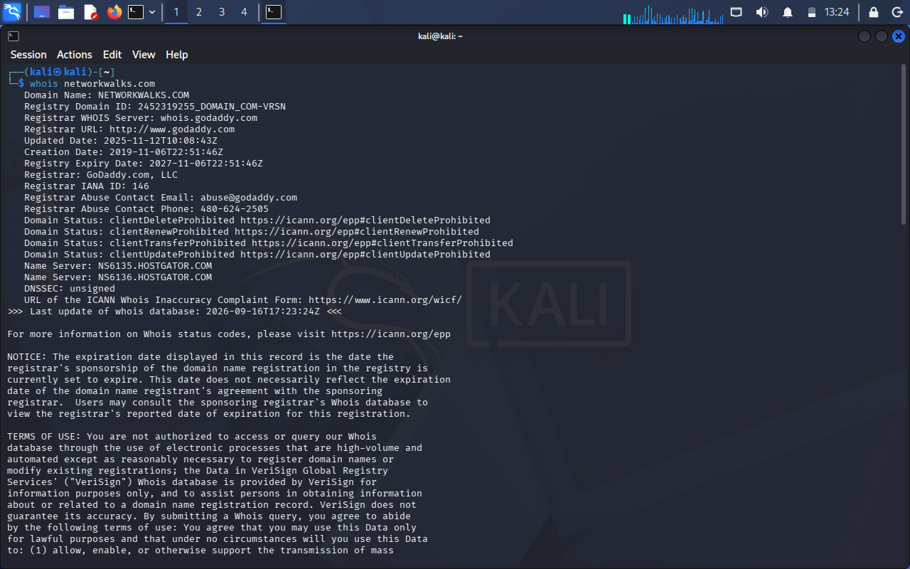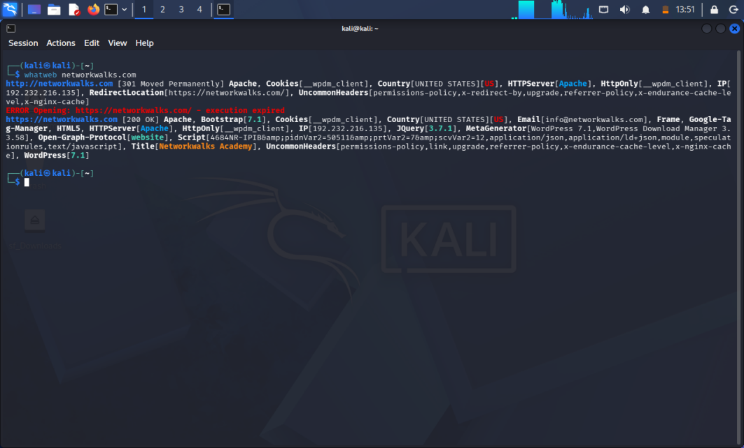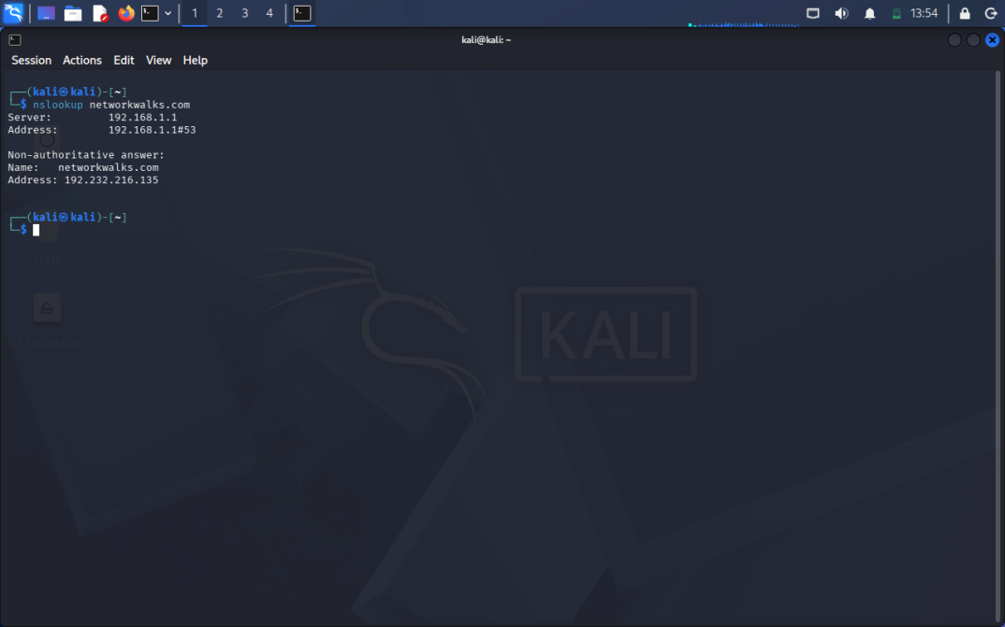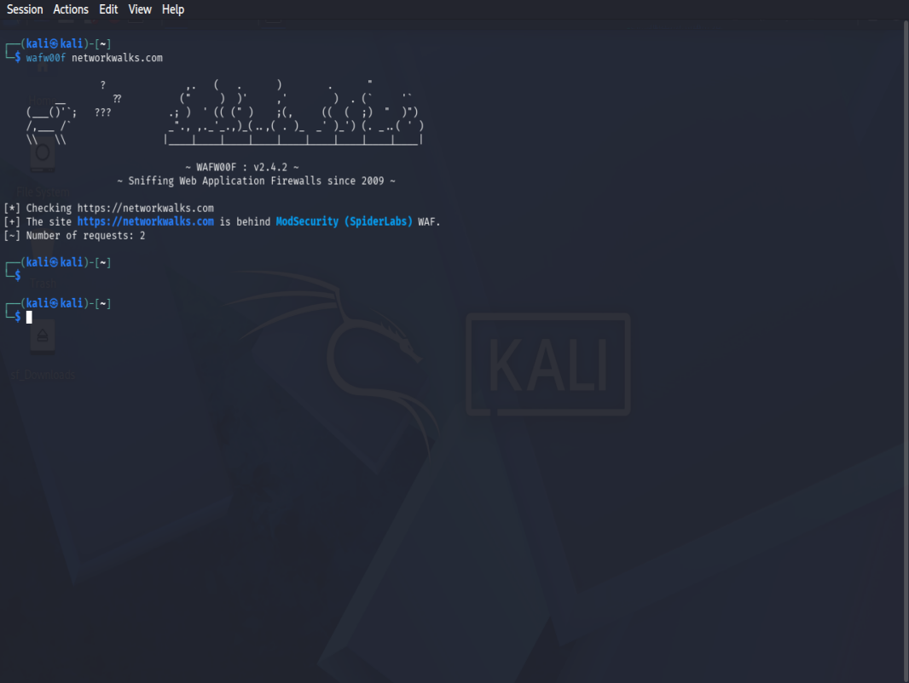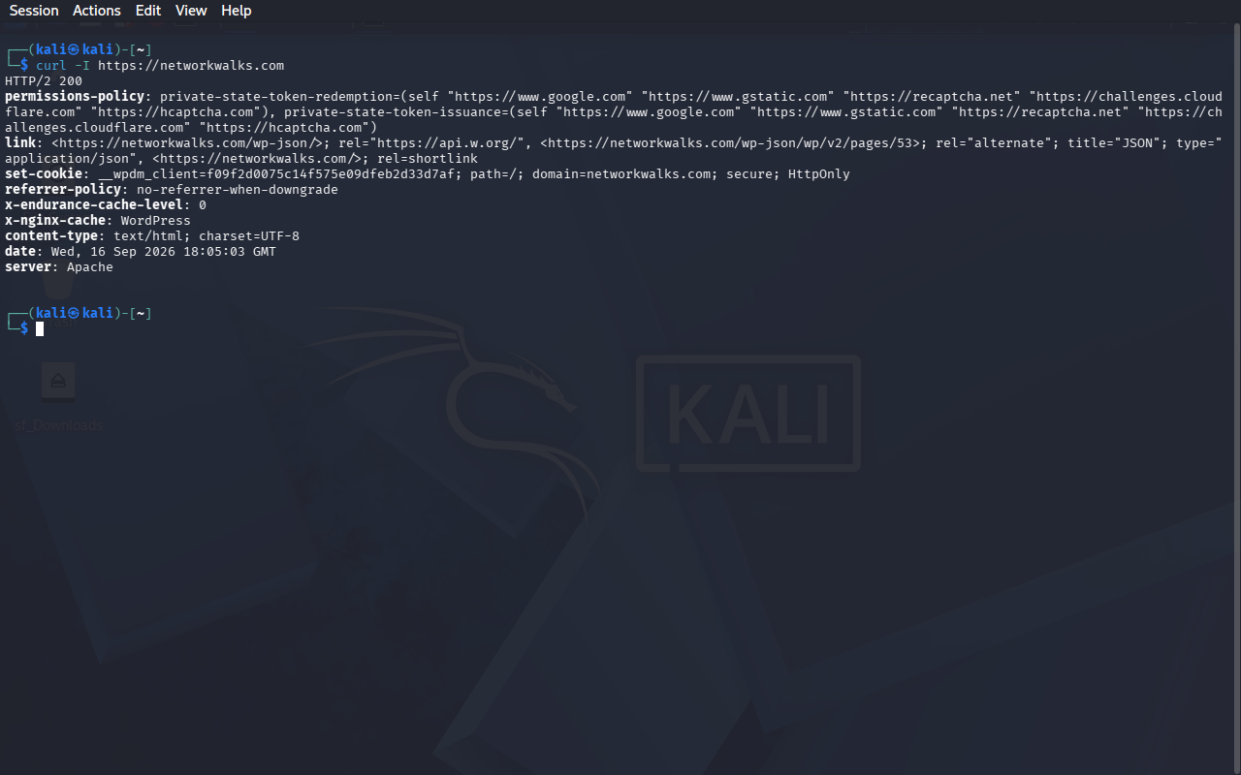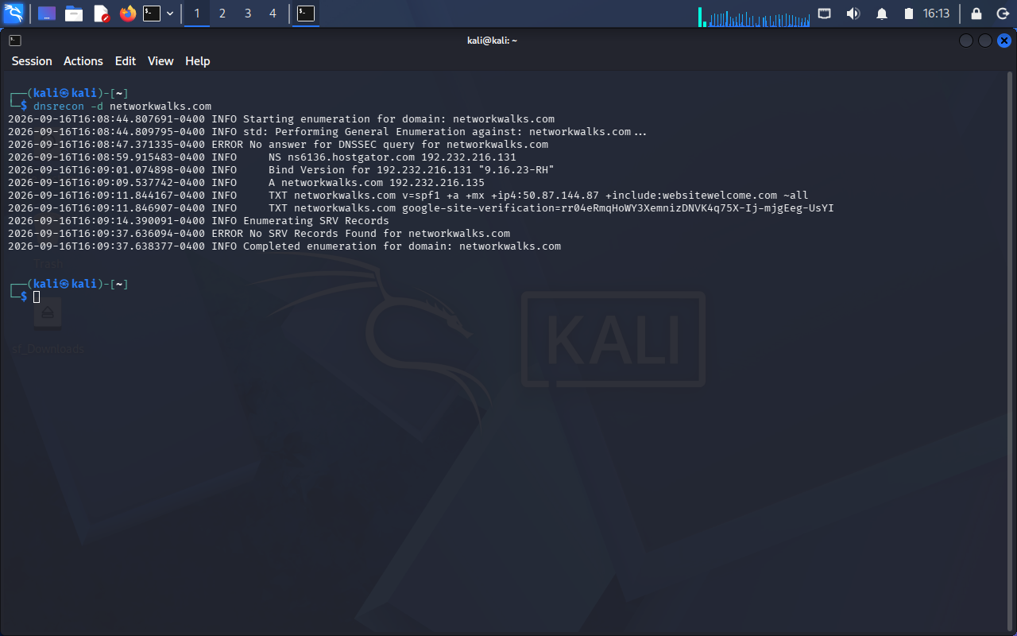

11. Project Information
Program: Cybersecurity & Ethical Hacking Internship
Organization: Networkwalks
Batch: B083
Week: 2
Project: Foot-printing & Network Scanning
Primary Platforms: Kali Linux and Windows
Primary Tools: WHOIS, WhatWeb, Nslookup, Curl, Wafw00f, DNSRecon, Nmap and Zenmap
Github Profile Link:

